Welcome First Graders! This is your supply list for 1st grade. Please bring the supplies to school on the first day of school on September 7, 2023.
欢迎一年级的学生们！这是我们一年级的所需物品。请大家在开学第一天9/7/2023带到学校。
Materiales para primer grado. Traiga a la escuela el primer dia de la escuela - 7 de septiembre.

3 Boxes of 12 Pencils (Dixon or  Ticonderoga)  3 cajas de 12 lápices ( Dixon  Ticonderoga)  3 盒铅笔（十二支）(Dixon/  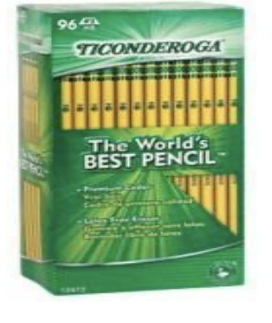  Ticonderoga) | (Please ensure that your child’s name is on their materials) 6 plastic folders: (solid colors only-no designs or characters) (1 green, 1 red, 1 blue, 1 orange, 1 yellow, 1 purple)  （确保标注孩子的姓名）6 个塑料文件夾（1 个绿色，1 个红色，1 个蓝色, 1 个橙色, 1 个黄色, 1 个紫色)  6 carpetas plásticas: (colores sólidos y sin diseños)  (1 verde, 1 roja, 1 azul, 1 anaranjada, 1 amarilla, 1 morado)  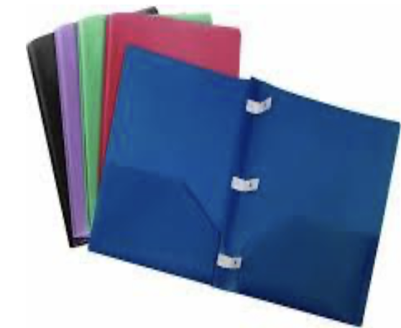
1 box of crayons (Crayola only)  1 caja de crayones (Crayola)  彩色蜡笔一盒（Crayola 牌子）  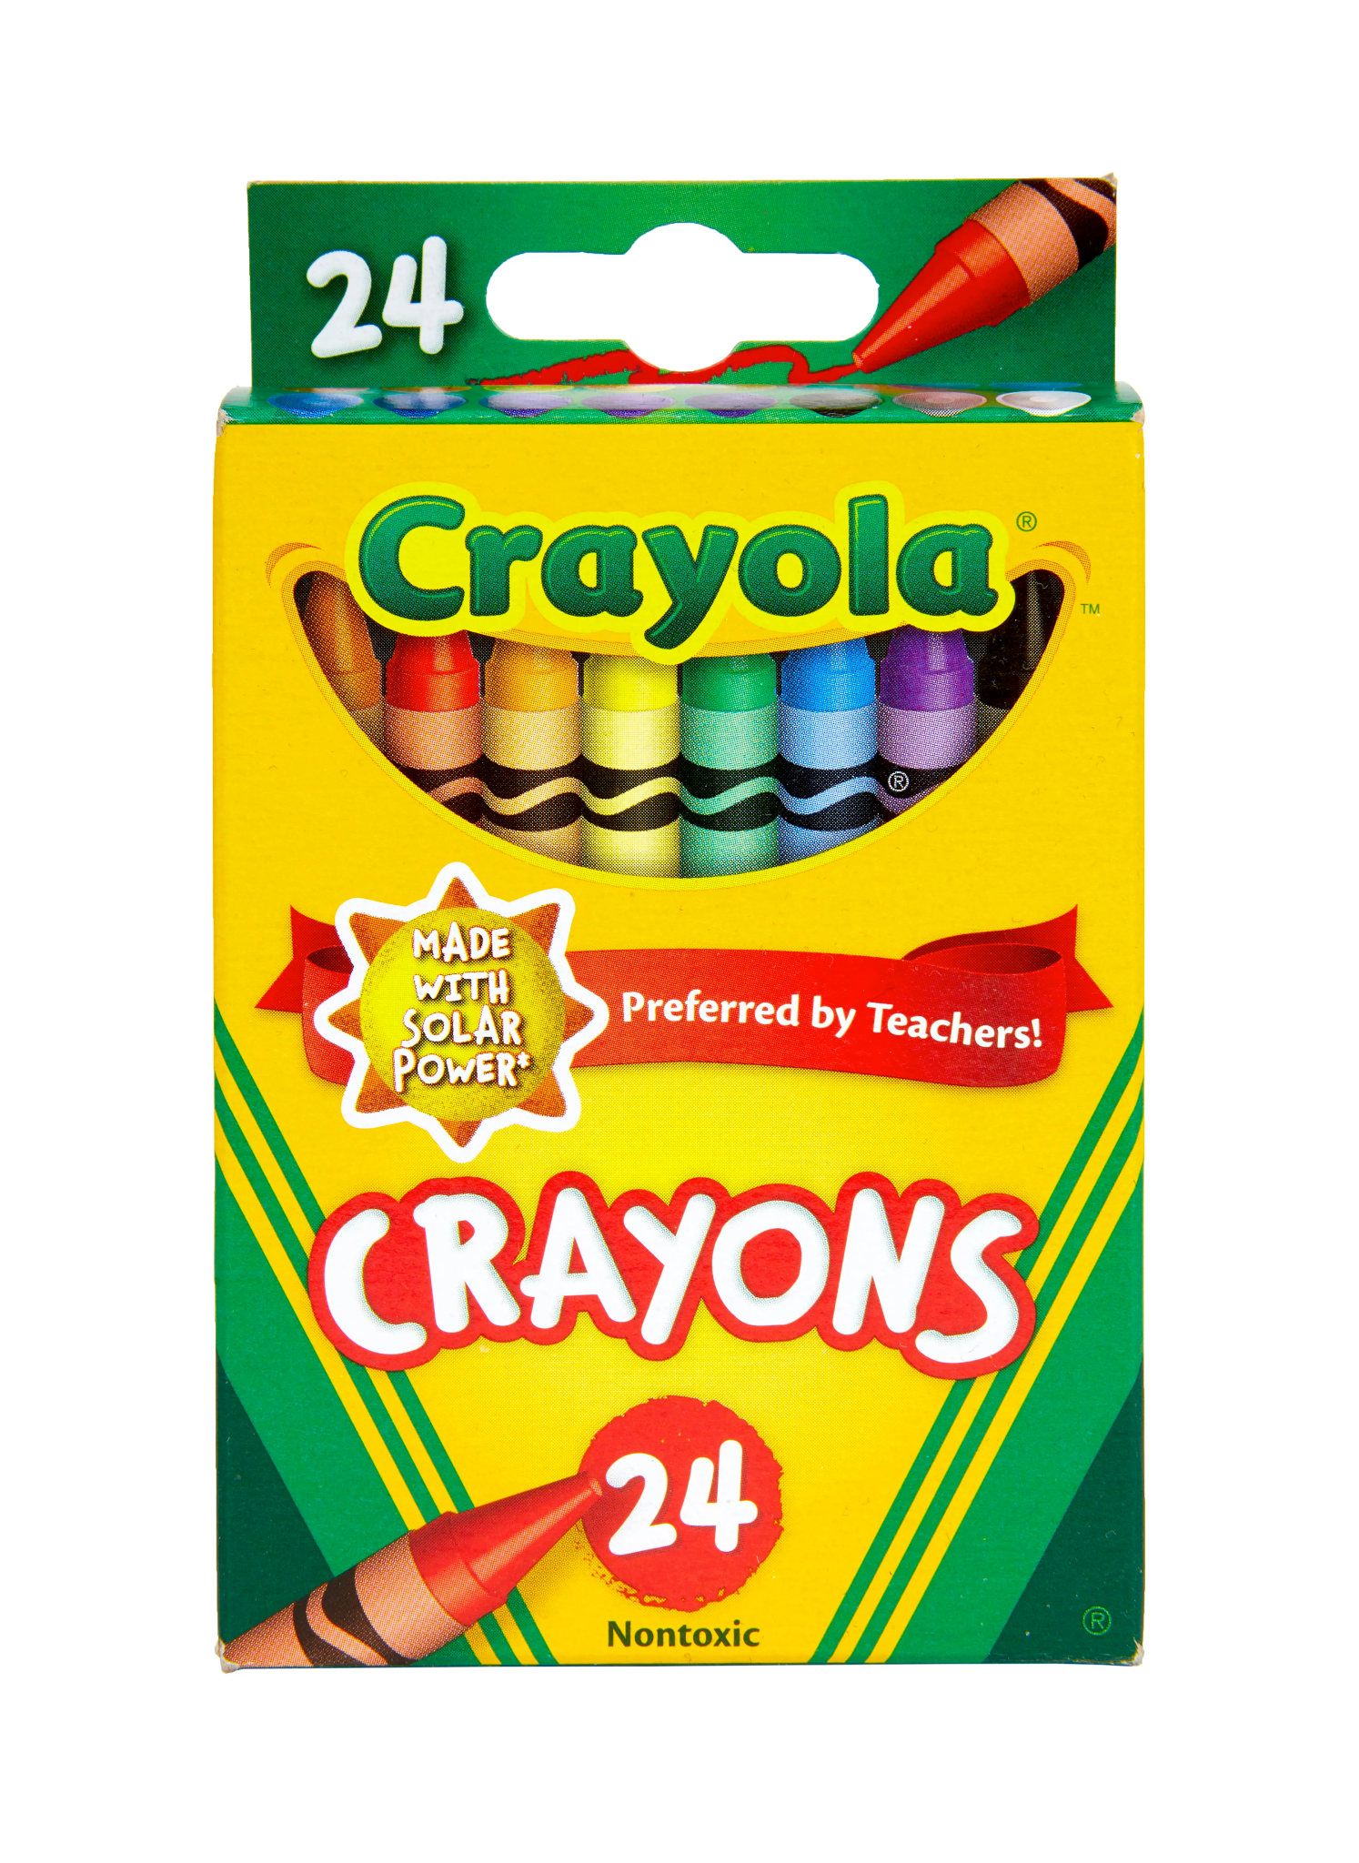 | (Please ensure that your child’s name is on their materials) 5 Marble Notebooks (Not spiral)  5 cuadernos (no de argollas)  （确保标注孩子的姓名）5 本笔记本（不要卷轴）  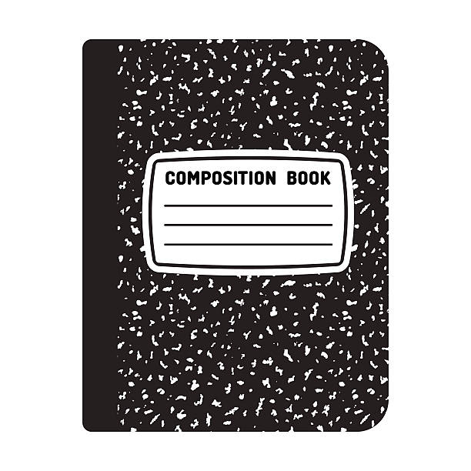
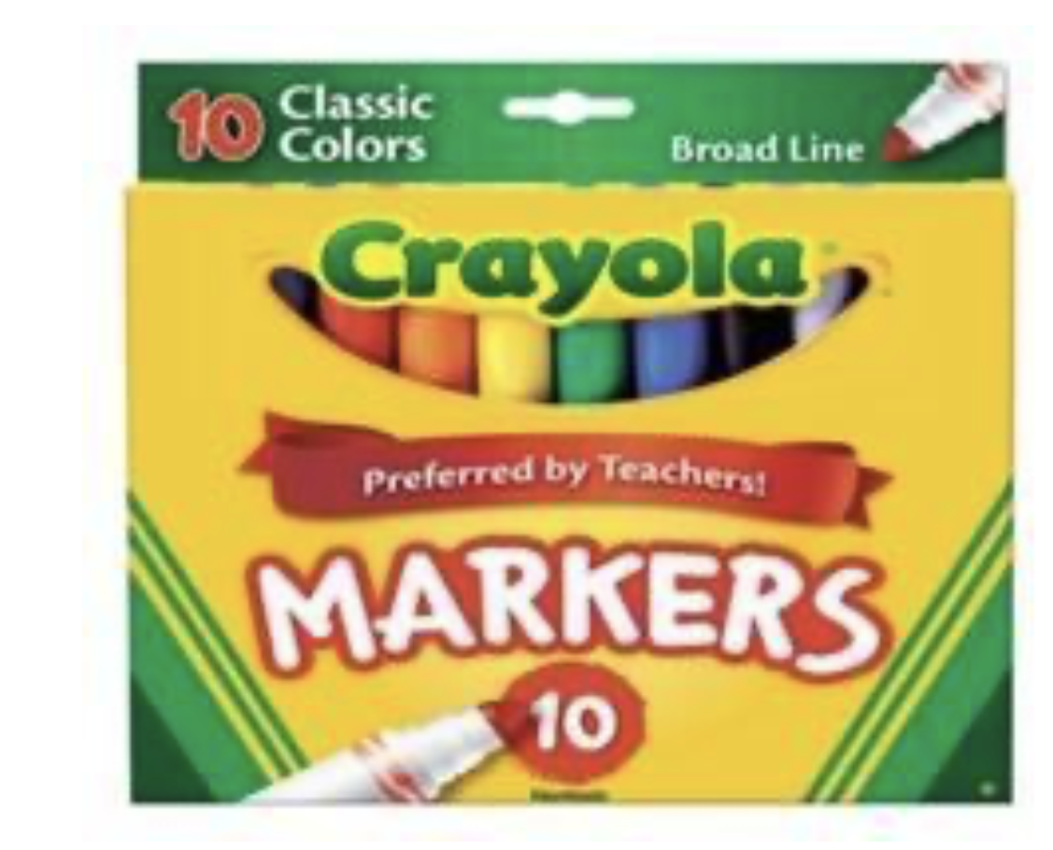  1 box of thick markers (Crayola) 1 caja de marcadores lavables (gruesos) (Crayola)  颜色墨水笔一盒 (Crayola) | 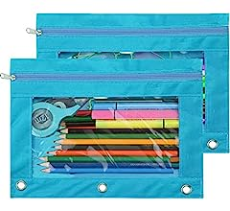  1 pencil bag (see picture below)  1 estuche para lápices  1 个铅笔袋
2 box of tissues (KLEENEX or PUFFS)  2 cajas de panuelos (KLEENEX or PUFFS) ! 盒面巾紙(KLEENEX 或 PUFFS)  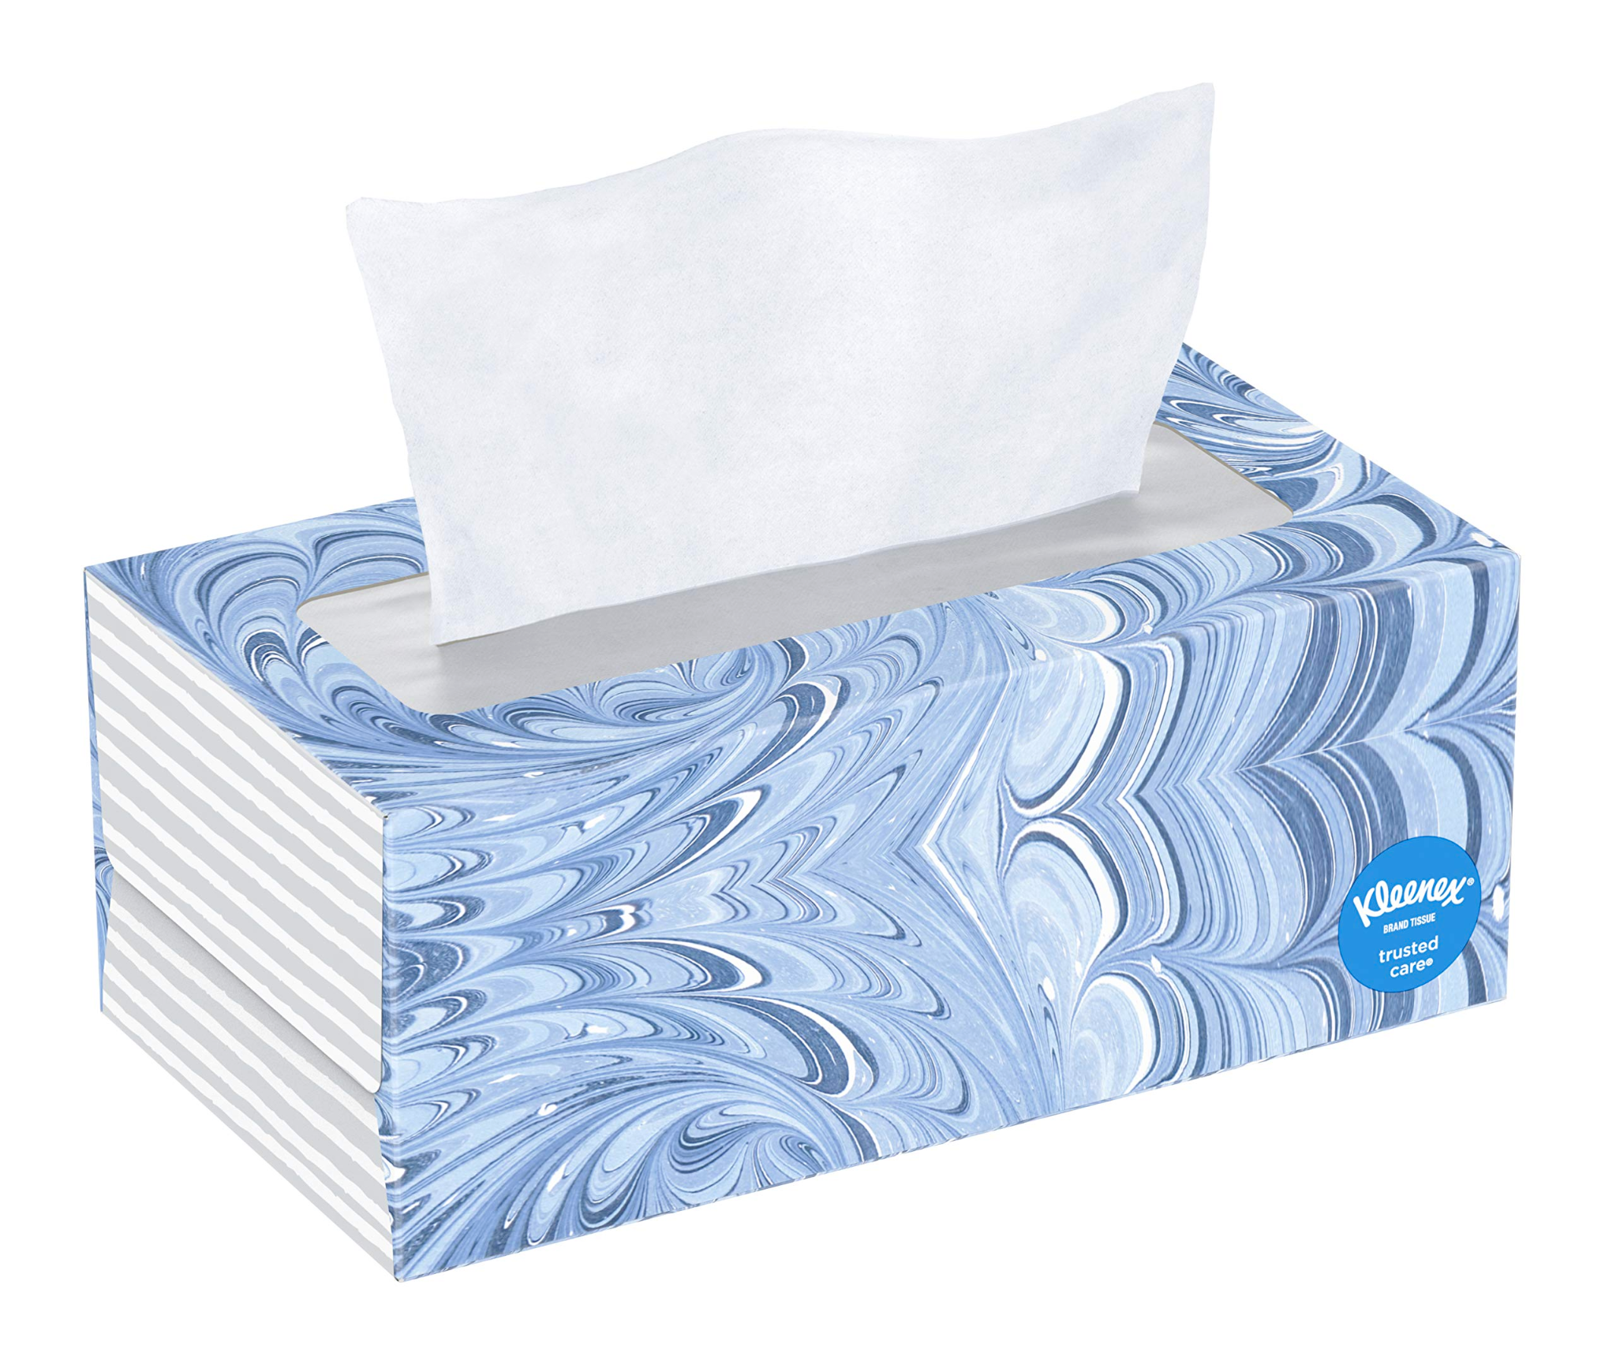  ​​ | 2 package of baby wipes (PAMPERS or HUGGIES)  2 paquete de toallas para bebes (PAMPERS or HUGGIES)  2盒幼兒清潔巾(PAMPERS 或 HUGGIES)  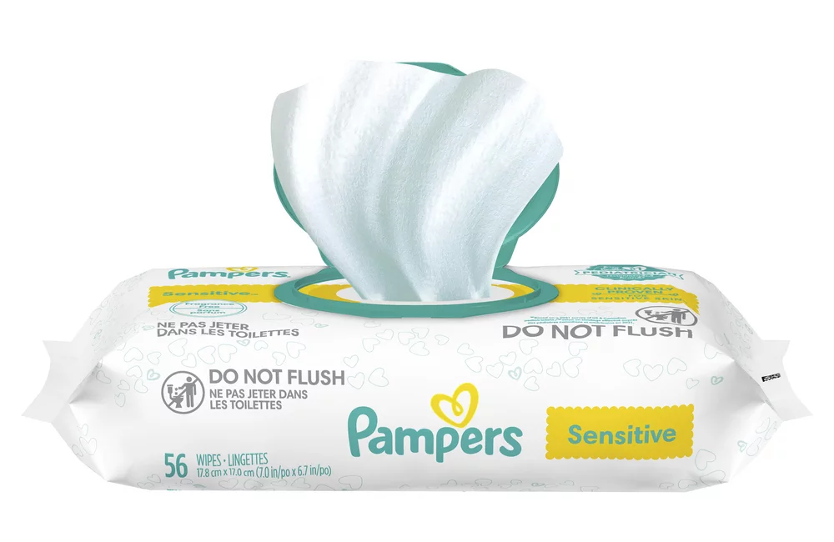
1 book baggie (see pictures below)  1 bolsita para libros  一个读书袋  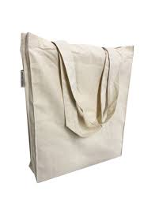  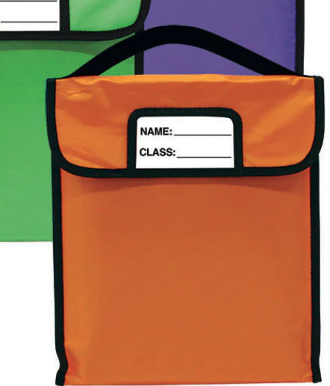 | 1 bottle of hand sanitizer (PURELL)  1 botella de desinfectante de manos  ! 瓶手清洁液  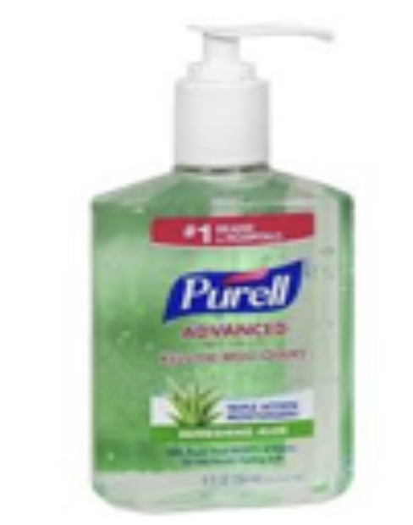
2 boxes of Zip baggies (1 large, 1 small)  2 cajas de fundas Ziploc (1 grande, 1 pequeña)  塑胶袋（1 大 1 小）  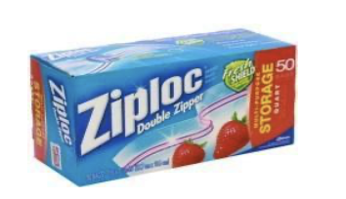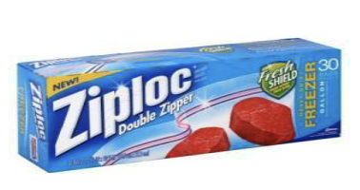 | 1 roll of paper towels (BOUNTY)  1 rollo de papel toallas (BOUNTY)  "卷厨房纸巾(BOUNTY)  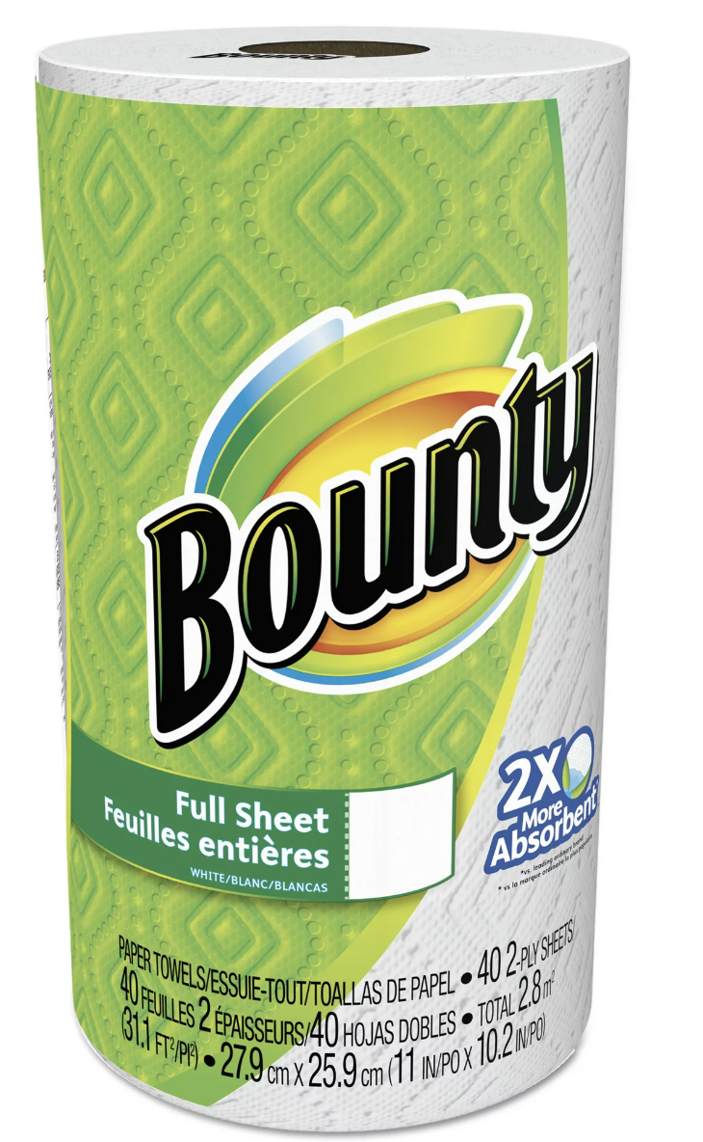
1 pack of Elmer’s glue sticks  1 paquete de Elmer’s pegamento  1 包 Elmer 胶棒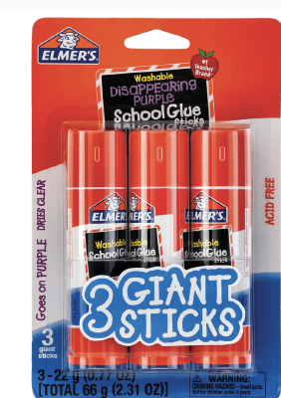 | 1 pack of pencil erasers  1 paquete de borradores  1 套橡皮擦  